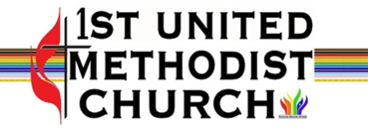

Who We Are –
We are an inclusive and safe congregation, living Jesus' hope for the world through justice and growing in God's love through study, fellowship, and active service to this community.
Inclusive Sunday Gathering 10:00
Songs, Sermon, Prayer, Open Communion
Nursery & Sunday School
Coffee Hour 11:00
What We Do --
Our remodeled historic building shelters ministries and service to the
Missoula community seven days a week, every week -- more than
10 recovery meetings (AA and Alanon), emergency winter overflow
shelter, sandwiches for the hungry, Green Team climate change
action, youth empowerment programs, Bible study group, Faith
studies groups, senior employment assistance, Scouting groups,
Angola pastor support and outreach, United Women of Faith
ministries, Afghan refugee/immigrant support; children’s community
choir, partnerships with Common Good Missoula, Missoula Interfaith
Collaborative, Poverello Center Homeless Shelter, Missoula
Foodbank, Missoula Ministerial Association.

For more information –
Questions: Call Catherine at the Church Office 9-12:00
Monday-Thursday, 406-549-6118
Email: fumcmissoula@gmail.com to be on our list for announcements and events
Website: https://www.firstumcmissoula.org/
Facebook: https://www.facebook.com/1stumcmissoula/
Please address all mail to: Post Office Box 7646
Missoula, MT 59807

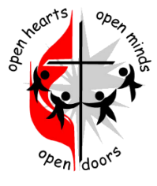
6th Sunday of Easter
Mother’s Day
May 10, 2026

Silent Reflection: “Sometimes serendipity is just intention unmasked.”
― Elizabeth Berg

Order of Worship
Welcome and Opening Prayer
Opening Song: “Rejoice, the Lord is King” #715
Children’s Time
Scripture: Acts 17:22-31
Message: “Hidden in Plain Sight”
Special Music
Prayers of the People -- Lord’s Prayer
Hymn: “Spirit of the Living God” #393
Communion
Closing Song: “I Need Thee Every Hour” #397
Closing Scripture/Benediction

Departing Meditation: “We reveal most about ourselves when we speak about others.”― Kamand Kojouri

OUR MISSION STATEMENT
(Taken from the Old Testament book of Micah, chapter six, verse 8)

“God has told you, O mortal, what is good; and what does the Lord require of you but to do justice, and to love kindness, and to walk humbly with your God?”
--Micah 6:8
Thank you for your generosity in helping us care for the Missoula community – you can donate by scanning the QR code to the left. Checks can also be sent by mail to: FUMC Missoula P.O. Box 7646, Missoula, Montana 59808
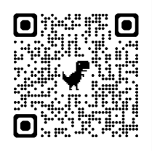

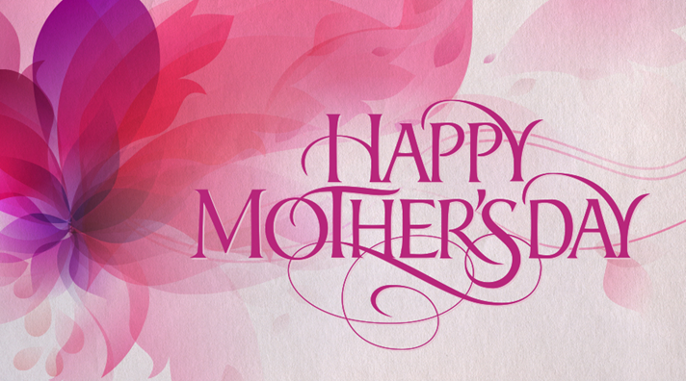
6th Sunday of Easter
Mother’s Day
May 10, 2026 - 10 a.m.
First United Methodist Church
Missoula, Montana

